English 11 Gregor’s Family Relationships
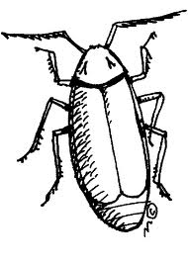

Directions: Describe Gregor’s relationship with each of the following family members by filling out the chart below.

 | DESCRIBE RELATIONSHIP THAT THIS PERSON SHARES WITH GREGOR INITIALLY | HOW DOES THIS PERSON CHANGE AFTER GREGOR’S TRANSFORMATION? | WHAT DOES THE CHANGE IN RELATIONSHIP WITH GREGOR TELL YOU ABOUT THIS PERSON? SIGNIFICANCE?
GREGOR’S FATHER
GREGOR’S MOTHER
GRETE (GREGOR’S SISTER)

